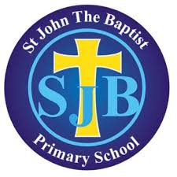

Parent/ Guardian Questionnaire
As part of our school development planning process, we are asking parents and guardians to complete a short multiple choice survey. This should only take a few minutes and will provide us with valuable feedback from across the school community which will be used to help shape and guide our actions moving forward, including for the new academic year beginning in late August.
The survey is available at the link below and will also be texted to parents.
https://sdp.wholeschool.ie/stjohnthebaptistps_1036688/questionnaire/e5cf03d6-8327-44e7-820e-83acde3e0768
It will close on Friday 6th May so we would ask you to ensure that it is completed in advance of that date.
Thank you,
C Donnelly
Principal

